**DAILY ONLINE ACTIVITIES SUMMARY**

|  |  |  |  |  |  |  |  |  |
| --- | --- | --- | --- | --- | --- | --- | --- | --- |
| **Date:** | **30-5-2020** | | | | | **Name:** | **Prajna** | |
| **Sem & Sec** | **8th sem ‘B’** | | | | | **USN:** | **4AL16CS067** | |
| **Online Test Summary** | | | | | | | | |
| **Subject** | | **-** | | | | | | |
| **Max. Marks** | | **-** | | **Score** | | | **-** | |
| **Certification Course Summary** | | | | | | | | |
| **Course** | **Frond end development html** | | | | | | | |
| **Certificate Provider** | | | **Great Learning** | | **Duration** | | | **30min** |
| **Coding Challenges** | | | | | | | | |
| **Problem Statement:**1**.** Write a c program to check the count of divisors within the randge | | | | | | | | |
| **Status: Completed** | | | | | | | | |
| **Uploaded the report in GitHub**  **GitHub link:** | | | | | **Yes**  **https://github.com/alvas-education-foundation/prajna_k** | | | |
| **If yes Repository name** | | | | | **prajna_k** | | | |
| **Uploaded the report in slack** | | | | | **yes** | | | |

Online Test Details: (Attach the snapshot and briefly write the report for the same)

Certification Course Details: (Attach the snapshot and briefly write the report for the same)

Coding Challenges Details: (Attach the snapshot and briefly write the report for the same)

2) certification course

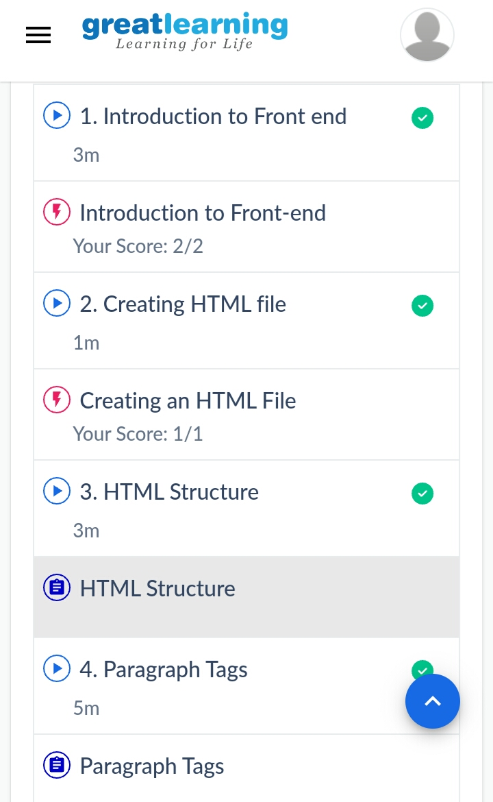

3) coding challenges

**Program 1**

* *#include* <stdio.h>
* int main(){
* int l,r,k;
* int i=0;
* int count=0;
* scanf("%d %d %d", &l,&r,&k);
* for(i=l;i<=r;i++)
* {
* if(i%k==0)
* {
* count++;
* }
* } *// Reading input from ST*

printf("%d",count);

|  |
| --- |
|  |
|  |  |
|  |  |
|  |  |
|  |  |
|  |  |